Navigating Crushers, Spreaders, and Substations at Singareni Mines

A Summer Internship Report
in
Electrical and Electronics Engineering
By
Deva Srinitha Patel (21701A0280)

Under the guidance of
Dr Venu
Professor (EEE DEPT)

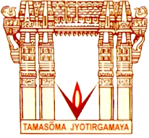

Department of Electrical & Electronics Engineering
VNR VIGNANA JYOTHI INSTITUTE OF ENGINEERING &TECHNOLOGY
AN AUTONOMOUS INSTITUTE
Bachupally, Nizampet (S.O), Hyderabad
Dec, 2023

VNR VIGNANA JYOTHI INSTITUTE OF ENGINEERING & TECHNOLOGY
AN AUTONOMOUS INSTITUTE
Bachupally, Nizampet (S.O), Hyderabad-500090
DEPARTMENT OF ELECTRICAL AND ELECTRONICS ENGINEERING

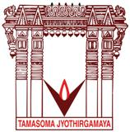

CERTIFICATE

This is to certify that Deva Srinitha Patel (21701A0280) have successfully completed their Summer Internship at Singareni Collieries Company Limited(SCCL), Hyderabad entitled “Navigating Crushers, Spreaders, and Substations at Singareni Mines”, in fulfillment of the requirements for the award of B. Tech degree.

Signature of Guide: Signature of Head of the Department
Dr. Y Venu Dr. Poonam Upadhyay
Professor Professor
Department of Elecrical and Department of Electrical and Electronics Engineering Electronics Engineering VNR VJIET VNR VJIET

VNR VIGNANA JYOTHI INSTITUTE OF ENGINEERING & TECHNOLOGY
AN AUTONOMOUS INSTITUTE
Bachupally, Nizampet (S.O), Hyderabad-500090
DEPARTMENT OF ELECTRICAL AND ELECTRONICS ENGINEERING

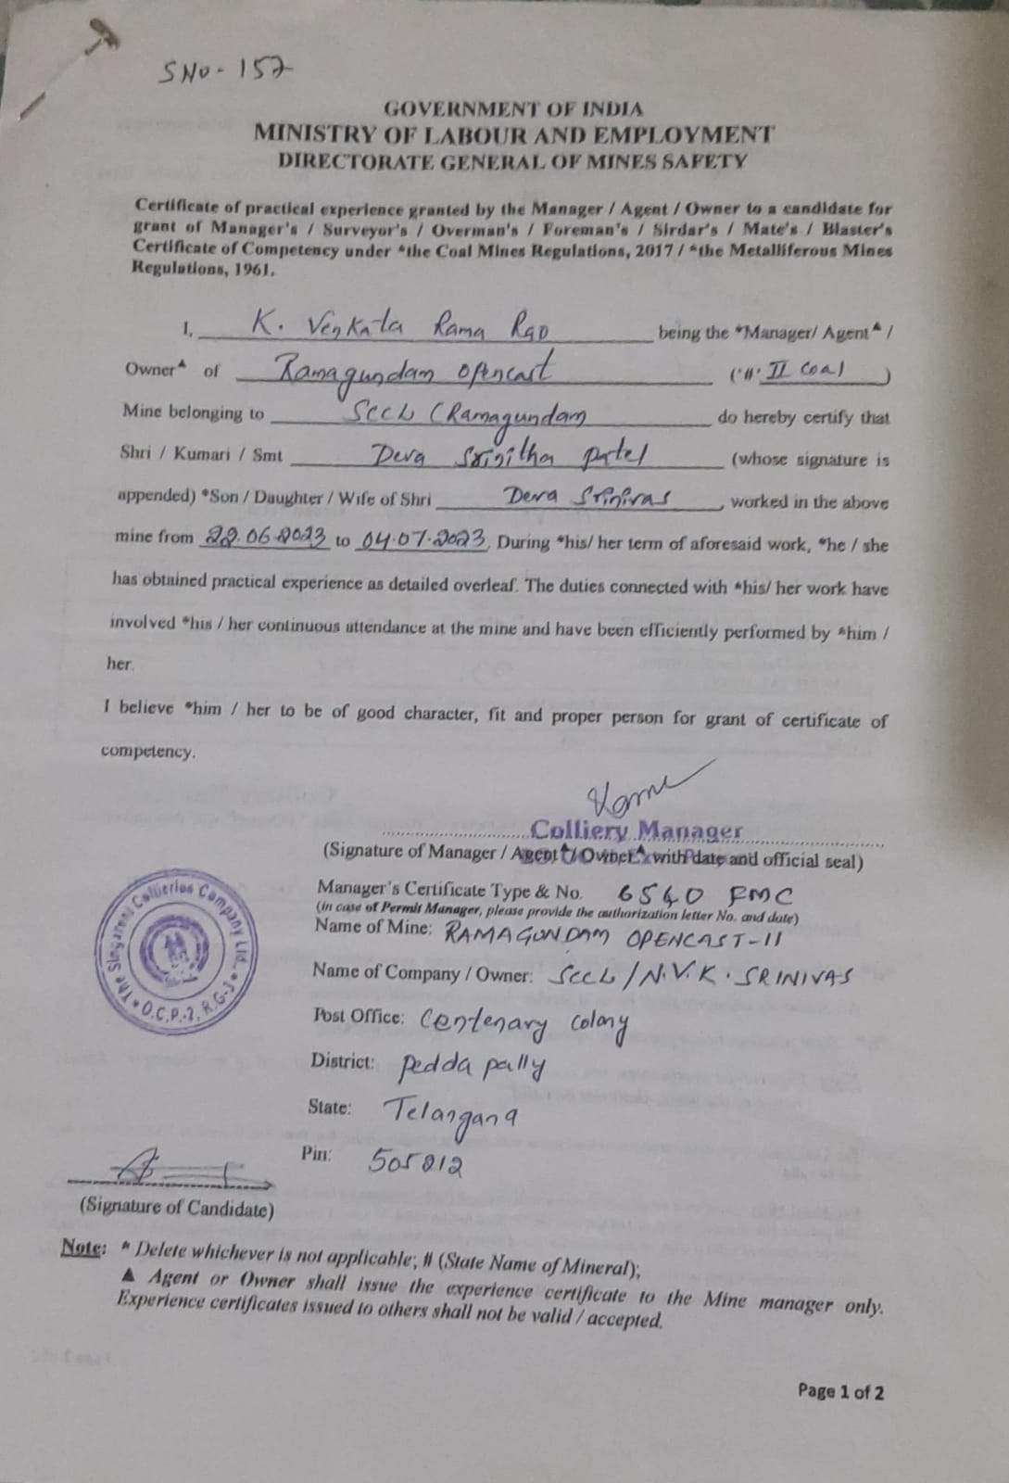
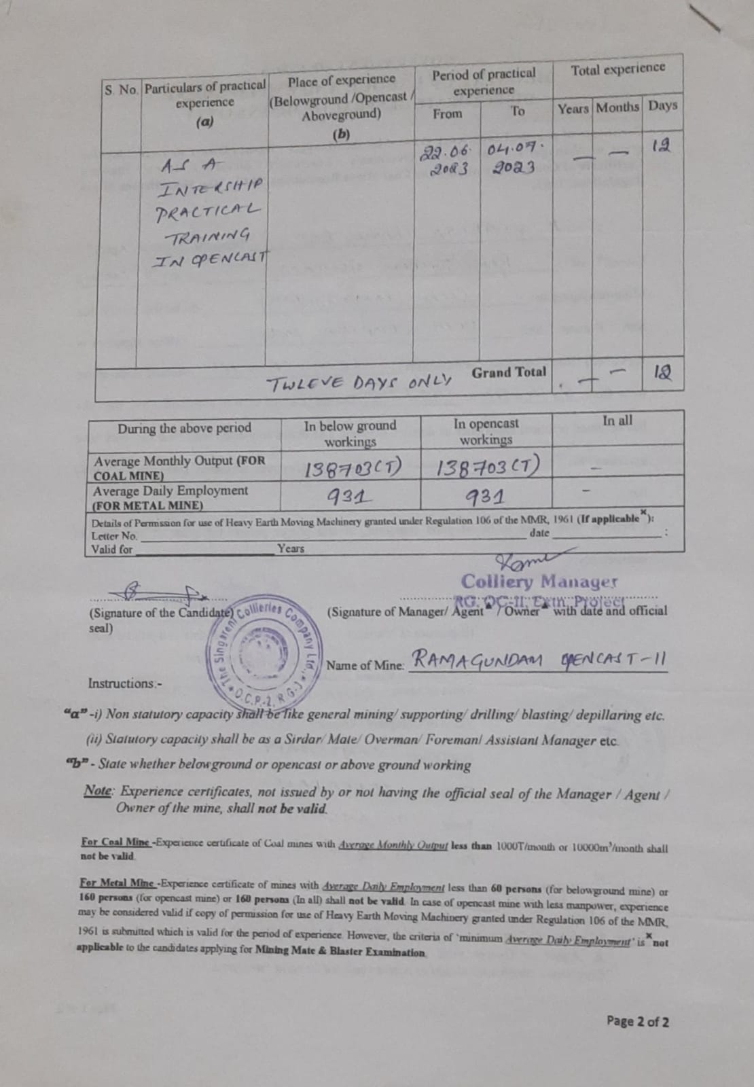

DECLARATION

We hereby declare that the Summer Internship Report entitled “Navigating Crushers, Spreaders, and Substations at Singareni Mines” is submitted in partial fulfillment of the requirements for the award of Bachelor of Technology in Electrical and Electronics Engineering at VNR Vignana Jyothi Institute of Engineering and Technology, An Autonomous Institute Hyderabad, is an authentic work showing our learning from the industry visit.

Name : Deva Srinitha Patel
Roll No : 21701A0280

ACKNOWLEDGEMENT

The satisfaction and euphoria that accompany the successful completion of any task would be incomplete without mentioning the people who have made it possible, because success is the epitome of hard work. So, with gratitude, we acknowledge all those whose guidance and encouragement have made our efforts successful We wish to express our deep sense of gratitude to our principal Dr. C.D. NAIDU and Head of the Department of Electrical and Electronics Engineering Dr.POONAM UPADHYAY for their encouragement, which went a long way in the successful completion of this project. We express gratitude to Dr. VENU, Assistant Professor, constant encouragement, and support of our Endeavours. We cannot ignore the support given by our parents who have always been inspirational. We thank every individual who has directly or indirectly influenced us to propel the project to its completion.
Abstract

Singareni Collieries Company Limited (SCCL) stands as a prominent state-owned coal mining company in India, contributing significantly to the nation's energy sector. Established in 1920, SCCL has played a crucial role in the development of the coal industry, particularly in the Singareni coal belt in Telangana. The company is known for its commitment to sustainable mining practices, technological innovation, and emphasis on safety. With a diverse range of mining operations, SCCL efficiently extracts and processes coal, contributing to both regional development and the national energy grid. SCCL's proactive approach to environmental concerns and its role in providing employment opportunities underscore its socio-economic impact. As a key player in India's coal industry, SCCL continues to evolve, adapting to advancements in technology and contributing to the nation's energy security.

CHAPTER I

INTRODUCTION

Singareni Collieries Company Limited (SCCL), a cornerstone in India's coal mining landscape, was established in 1920. Headquartered in Kothagudem, Telangana, SCCL has emerged as a vital player in the country's energy sector. Operating in the heart of the Singareni coal belt, the company has been instrumental in harnessing the rich coal reserves of the region, contributing significantly to both regional development and the nation's energy grid.

With a legacy of over a century, SCCL has not only adapted to technological advancements in coal mining but has also set benchmarks for sustainable and responsible practices. The company's commitment to safety, environmental stewardship, and community welfare reflects its integral role in the socio-economic fabric of the region. This introduction sets the stage for exploring SCCL's multifaceted contributions to India's coal industry and its enduring impact on the energy landscape.

Singareni Collieries Company Limited (SCCL) is the main source for supply of coal to the southern region. The company produced 65.02 million tonnes of coal during 2021-22 as against 50.58 MT during the same period of previous year. SCCL production of coal during 2022-23 was 67.14 MT with a positive growth of 3.26%. Small quantities of coal are also produced by TISCO, IISCO, DVC and others.

Singareni Collieries Company Limited (SCCL) is situated in southern part of India and having its operations in six districts of northern Telangana i.e., Kumuram Bheem Asifabad, Mancherial, Peddapalli, Prof. Jaya Shankar Bhoopalpalli, Bhadradri Kothagudem & Khammam Districts. SCCL is supplying coal to most of the customers situated in Telangana and to some extent in southern parts of India and some parts in Maharashtra. SCCL has produced 62.01 Million tonnes of coal during 2017-18 and dispatched 64.62 Million Tonnes of coal to various categories of consumers during 2017-18 and set a production target of 65.00 Million Tonnes for the year 2018-19. SCCL is operating 29 underground mines and 19 Opencast mines to meet the linkage requirements of major Power (66%), Cement (13.5%), Captive Power (6.6%), Sponge Iron (3.1%) and other Customers (10.8%). SCCL is a Pioneer in introduction of various state of the art underground technologies in its mines such as Longwall, Blasting Gallery and Continuous Miner technologies etc.
CHAPTER II

703 SPREADER

The 703 Spreader is a large heavy equipment machine used in surface mining. The primary function is that of a continuous digging machine in large-scale open-pit mining operations, removing thousands of tons of overburden a day. What sets them apart from other large-scale mining equipment, such as bucket chain excavators, is their use of a large wheel consisting of a continuous pattern of buckets which scoop material as the wheel turns. They are among the largest land or sea vehicles ever produced.

The spreader mining machine utilized in Singareni, typically referred to as a spreader, is a crucial equipment in open-pit mining operations. This massive machine is designed to efficiently handle overburden and facilitate continuous mining processes.

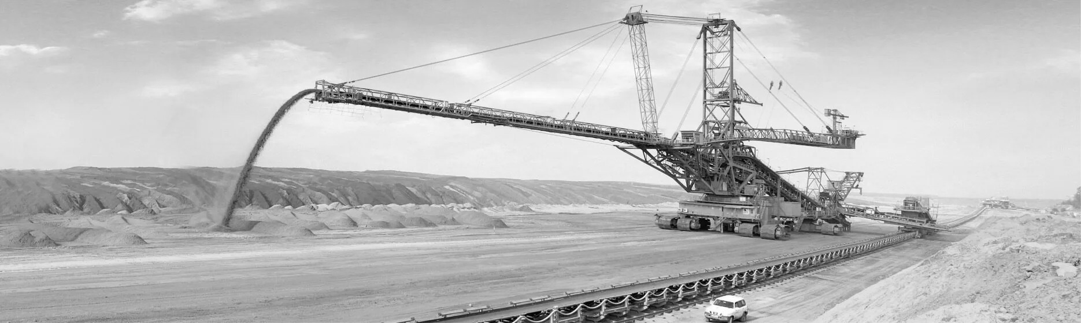
The primary function of the spreader is to transport overburden materials, such as soil and rocks, from the mining area to designated dumping locations. It achieves this by using a conveyor system that extends over the mining pit. The conveyor belt carries the excavated material to the spreader's discharge boom, which can rotate and distribute the material evenly across the dumping site. The spreader offers several advantages in large-scale mining operations. It enhances the efficiency of material handling, enabling a continuous flow of excavation and removal. This not only increases the overall productivity of the mining process but also minimizes downtime.

Singareni, being a significant coal mining company, relies on spreader machines to efficiently manage the overburden removal process in their open-pit mines. These machines play a vital role in optimizing the extraction of coal resources while ensuring the safety and efficiency of mining operations.

It can excavate 240,000 tons of coal or 240,000 cubic metres of overburden daily the equivalent to 30 m (98 ft) deep. The coal produced in one day fills 2400 coal wagons. The excavator is up to 220 m (721 ft) long (slightly shorter than Baggers 287 and 293) and approximately 96 m (315 feet) high. The Bagger's operation requires 16.56 megawatts of externally supplied electricity. It can travel 2 to 10 m (6.6 to 32.8 ft) per minute (0.1 to 0.6 km/h). The chassis of the main section is 46 m (151 ft) wide and sits on three rows of four caterpillar track assemblies, each 3.8 m (12 ft) wide.

CHAPTER III

CRUSHER

A coal crusher is a machine that is used to crush coal into smaller pieces. Coal crushers are used in coal handling plants to crush coal into small pieces that are easy to transport. They are also used in coal processing plants to crush coal into smaller pieces that can be used to make electricity.

There are many different types of coal crushers, but they all work by applying pressure to the coal to break it into smaller pieces. The most common type of coal crusher is the jaw crusher. Jaw crushers have two jaws that move towards each other, crushing the coal between them. Another common type of coal crusher is the impact crusher. Impact crushers use a hammer or other impactor to break the coal into smaller pieces. Coal crushers are an important part of the coal industry. They allow coal to be transported and processed more easily, and they also help to make electricity more affordable.

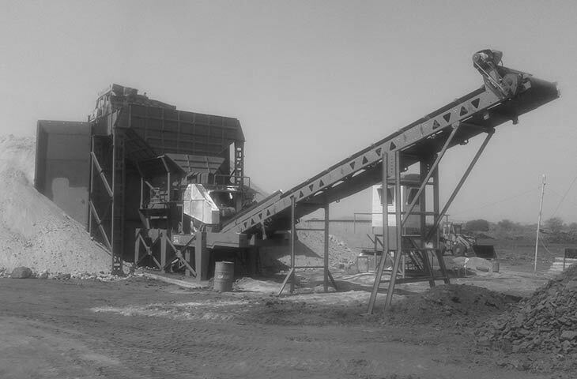

Mining operations use crushers, commonly classified by the degree to which they fragment the starting material, with primary and secondary crushers handling coarse materials, and tertiary and Quaternary crushers reducing ore particles to finer gradations. Each crusher is designed to work with a certain maximum size of raw material, and often delivers its output to a screening machine which sorts and directs the product for further processing. As well as size, machines designed for each of these stages must take into account the basic methods of material size reduction, impact, compression, attrition, and cutting. Depending on the material properties and desired outcome some methods of crushing and thus machines designs may be more appropriate for the use case.
Typically, crushing stages are followed by milling stages if the materials need to be further reduced. Additionally rock breakers are typically located next to a crusher to reduce oversize material too large for a crusher. Crushers are used to reduce particle size enough so that the material can be processed into finer particles in a grinder. A typical processing line at a mine might consist of a crusher followed by SAG MILL followed by a BALL MILL. In this context, the SAG mill and ball mill are considered grinders rather than crushers.

CHAPTER IV

33Kv/6.6Kv POWER SUBSTATION

A 33kV/6.6kV substation refers to an electrical substation that transforms voltage levels from 33,000 volts (33kV) to 6,600 volts (6.6kV).

33kV:
This is the high voltage level on the incoming side of the substation. Electricity is typically transmitted over long distances at high voltages to minimize energy loss during transmission. The 33kV voltage level is common in medium-voltage transmission systems.

6.6kV:
This is the lower voltage level on the outgoing side of the substation. The purpose of the substation is to step down the high voltage (33kV) received from the transmission lines to a lower, more manageable voltage for local distribution. In this case, the output voltage is 6.6kV.

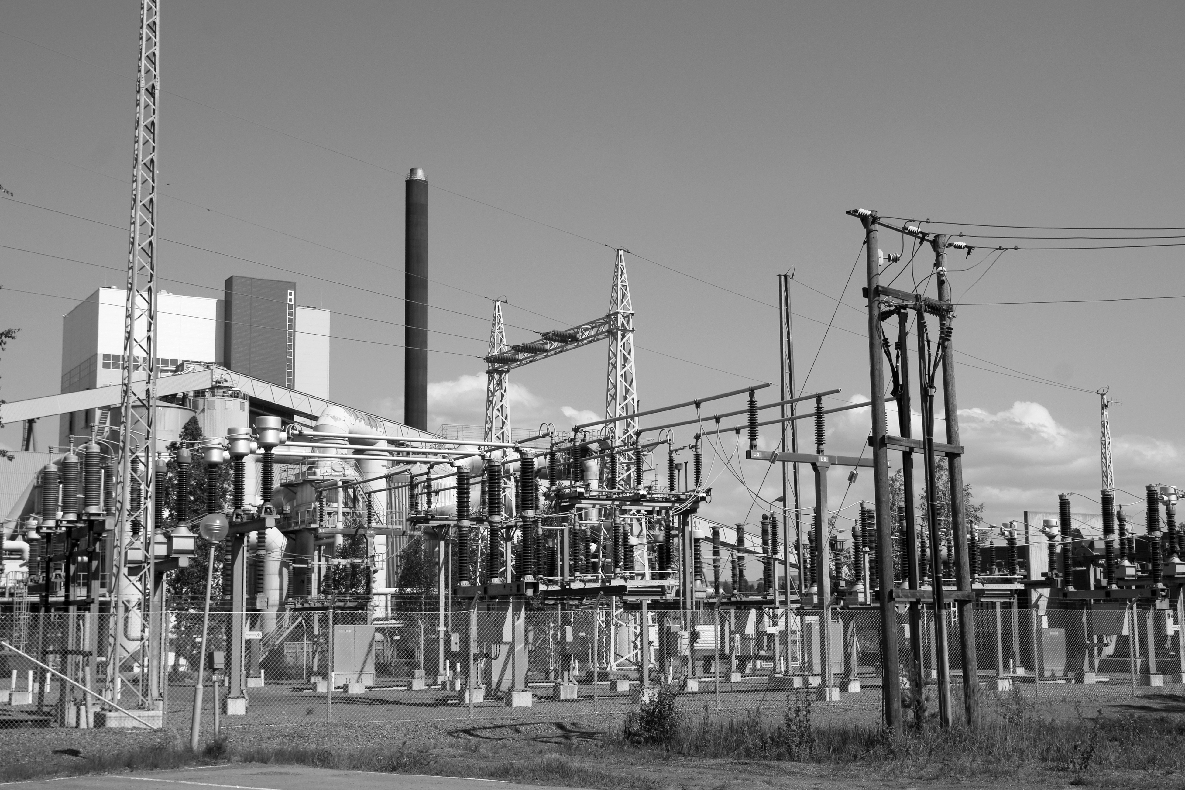

A 33kV/6.6kV substation is a type of electrical substation that steps down voltage from 33,000 volts to 6,600 volts. This is done using a transformer, which is a device that transfers electrical energy from one circuit to another through electromagnetic induction. The 33kV voltage is typically used for transmission, while the 6.6kV voltage is used for distribution.

33kV/6.6kV substations are often used in rural areas, where the load density is low. They can also be used in industrial areas, where there is a high demand for power.

The main components of a 33kV/6.6kV substation are:
- Transformers: The transformers step down the voltage from 33kV to 6.6kV.
- Switchgear: The switchgear is used to isolate and protect the equipment in the substation.
- Control equipment: The control equipment is used to monitor and operate the substation.

